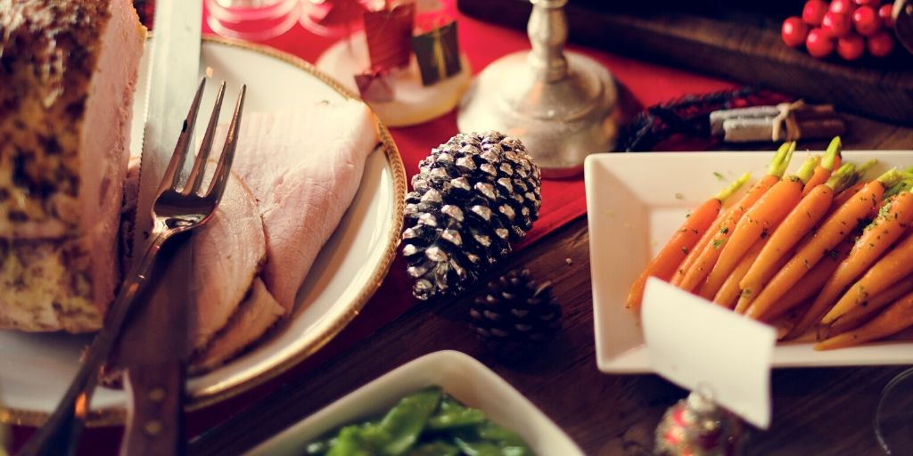

VIRTUAL HOLIDAY COOKING
WITH CHEF FRED



Ingredient Shopping List

Below is a list of ingredients you’ll need to make the recipes in this packet. Please reach out for substitution suggestions.

Main
⇨ Salmon
⇨ Shrimp

Produce
⇨ 1 medium sweet onion
⇨ 1 lemon
⇨ 1 red bell pepper
⇨ ½ garlic bulb
⇨ ½ pound mushroom
⇨ 1 head of leafy lettuce

Dairy
⇨ Unsalted butter
⇨ Lite Mayo

Pantry Items
⇨ Kosher or sea salt
⇨ Freshly ground black pepper
⇨ Olive oil
⇨ Crushed red pepper flakes
⇨ Lemon pepper
⇨ Dijon mustard
⇨ Parchment paper

Equipment Needed

Below is a list of tools you’ll need to make the recipes in this packet.

Cutlery
⇨ Chef’s knife
⇨ Paring knife
⇨ Cutting board

Hand Tools/Gadgets
⇨ Measuring cups and spoons
⇨ Mixing bowls (various sizes)
⇨ Tongs
⇨ Cooking spoon
⇨ Citrus juicer (optional)
⇨ Fork
⇨ Spoons for tasting
⇨ Spatula

Cookware
⇨ 2 Large skillets with lids

Bakeware
⇨ Rimmed baking sheet

Tabletop
⇨ 1 medium-sized serving platter
⇨ 1 medium-sized serving bowls
⇨ Serving utensils

Pre-Class Notes

- Please gather all ingredients before class if you will be cooking along.
- We encourage you to prep all your ingredients prior to class as it will allow you to have more time to listen and watch the chef.
- Preheat oven to 3500°F.

All Recipes
1. Have all produce washed and dried.

